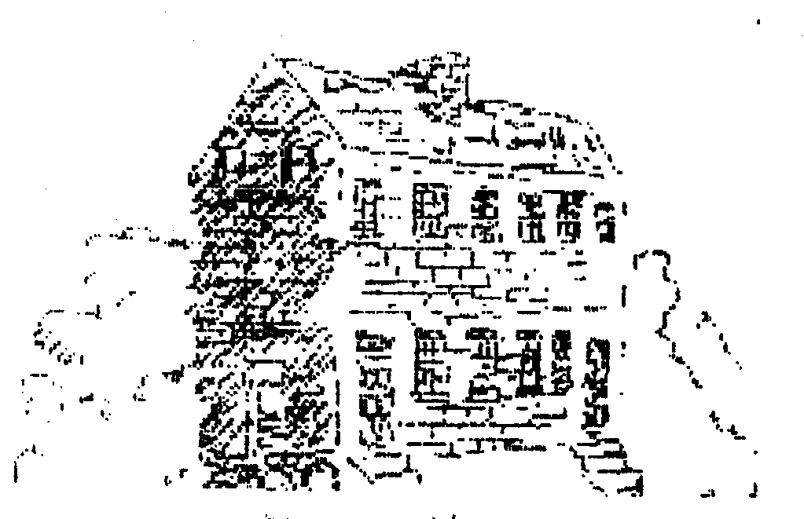 THE LAUREL LIGHT
March 5, 2004 Volume VIII, Number 1 News from the Laurel Historical Society and The Laurel Museum
www.laurelhistory.org

Upcoming Calendar & Meeting Notice:

March 11th Program:
Families and Flight 1790-1860 7:30 at the Pool Meeting Room
April 3rd Gala: A Night in Oz Honoring Gertrude Poe
April 29th Board of Directors Meeting
7:30 at the Pool Meeting Room
May 6th Annual Meeting and Elections
7:30 at the Pool Meeting Room
May Horace Capron at 200: A Founder’s Life Special Exhibit celebrating the 200th Anniversary of the birth of Horace Capron.
June 12th Annual Picnic and dedication of the Landscaping project made possible by donations in Honor of Elwood Fisher. Events begin at 10:00 AM at the Museum

“The Plantation Underground of Prince George’s County: Families and Flight, 1790 – 1860” Scheduled for March 11
Learn more about slavery in Prince George’s County, the underground railroad and other ways people escaped. March 11 at 7:30 p.m. the Laurel Historical Society’s featured speaker will be David Terry, PhD, a Research Specialist at the Maryland State Archives (MSA). Dr. Terry heads a project that examines the flight from slavery in Maryland. Dr. Terry will discuss what he and his team have discovered about slavery, escapes and particularly about Prince George’s County in creating the fascinating Maryland Archives website: www.mdslavery.net. Location: Laurel Pool Club Room, 9th & Main. Members Free, Non-members $3.00. For more information call 301-725-7975

Laurel Historical Society Honors Gertrude Poe

One of Maryland’s pioneering journalists: Gertrude Poe, is the honoree for this year’s Laurel Historical Society Gala: “A Night in Oz.” being held April 3, 2004 in the Carriage Room at Laurel Park Race Course.
Gertrude Poe served as editor, publisher and owner of the Laurel Leader for 40 years. A pioneer for women in Journalism, She was the first woman president of the Maryland-Delaware-DC Press Association (1958), and in 1987 was elected to its Hall of Fame. In 1970 she edited the book on Laurel’s history for its Centennial celebration that is still a basic resource today. She has endowed many merit scholarships in journalism at the University of Maryland, and has long been a supporter of the arts. Her most recent honor was to be featured in “Women of Achievement in Maryland History” published in 2002. She is currently a resident of Ashton, Maryland
“A Night in Oz” will include also include a silent auction—including vacations, lunches with local city leaders, artwork, design and other items. By popular request, Swing Time Big Band and their terrific vocalist will return to provide music from the Wizard of Oz and other popular songs. Detailed sponsorship, table and invitation information can be obtained by calling 301-562-GALA.

The Laurel Historical Society is proud to have the following Community Business and Professional Partners:
The Citizens National Bank
The Laurel Leader

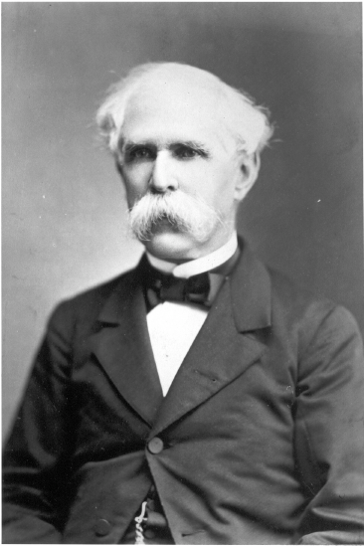

Horace Capron at 200:

A Founder’s Life

2004 marks the 200th Anniversary of the birth of Horace Capron, a key figure in Laurel, Maryland’s early years. Capron married Louisa Snowden and was a founder of the Patuxent Manufacturing Company, a leading agricultural figure in Maryland, builder of Laurel’s Historic homes, Civil War General, and a pioneer developer of the Japanese province of Hokkaido. This Spring the Laurel Museum will open an exhibit on Capron’s life that will feature items relating to his time in Laurel and after. Visitors will get a chance to see an original Mill ledger, a copy of the original charter for the Patuxent Manufacturing Company; a copy of Capron’s Civil War history of Stoneman’s raid, and other items related to his work in Japan. The exhibit opens in early May. Watch for it!

The Laurel Light
Published periodically by:
The Laurel Historical Society Inc. 817 Main St.; Laurel, MD 20707-3429
Editor: Marlene Frazier
marlene.frazier@verizon.net

Celebrate The Greatest Generation with a 2004 Victory Garden

Now is the time to start your seeds for this year’s Victory Garden. Victory Garden seed kits are again available at the Museum Shop.
Starting in 1943, Americans from coast to coast planted Victory Gardens promoted by the Department of Agriculture to support the WWII effort and save products for those overseas.
More than 20 million Americans are reported to have planted Victory Gardens—and the effort was supported by government agencies, private foundations, businesses, schools and seed companies.
The Laurel Museum is participating in the America Celebrates the Greatest Generation events around Memorial Day that are part of the dedication of the WWII. As part of our program, Laurel Historical Society member Dave Mann, working with Heirloom Gardens in Alabama, developed the Victory Garden kit. In the kit people will find many common and heirloom varieties of seeds, plus some of their history. Most of these would have been varieties available to Victory gardeners. Seeds include:

Trophy Tomato (originated in Maryland, 1870)
West India Burr Gherkin Cucumber
Crisp Mint, Pirat, and Australian Yellowleaf Lettuce
Willowleaf Pole Lima Bean
Dragon'sTongue Bush Bean
Danver's Half Long Carrot
Stowell’s Evergreen Corn
Bull’s Blood Beet
Prussian Blue Pea
Martin’s Carrot Pepper

The seed kit is available for $10 at the Laurel Museum shop.

Share Your History With the LHS

Have you researched your family’s Laurel roots? Do you have information about events that took place in Laurel years ago? Have you done an in-depth search of your house's history? Your findings can help us in developing future exhibits and in expanding our source materials for researchers.
The LHS John Calder Brennan Library is an important local resource for researchers. We get several requests each week for information about the history of the town and its people. Please share your findings of Laurel-related family genealogies, house or personal research, or photographs of local people, places, and events which can be copied. It could be an important source of information to someone in the future.
Call Carol Runyon at the Laurel Museum, 301-725-7975, or e-mail at
curator@laurelmuseum.org
Thank you to R.L.Thompson Electrical for the wonderful new light at the front of the Museum.

Welcome New Members:
Karoline Black
Nicholas Drummond
Patricia Elliot
Judith Haxton
Scott, Holly & Madeline
Lillienthal
Mary Miller
Cyrena Veitch
In Memoriam: We regret to report that long time member, Earl Snyder died on January 11th. Mr. Snyder was a Director Emeritus of the Board of Directors and was one of the first major contributors to the endowment fund. We are grateful for his service and advice through the years.
Volunteer of the year for 2003
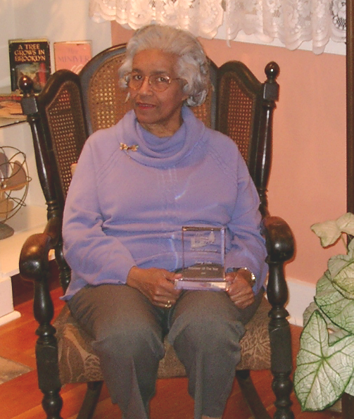
The Laurel Historical Society honored volunteer of the year Ivary Doles at the Volunteer appreciation party on January11th. Ivary has been a very active docent and her enthusiasm as a researcher has assisted many members and visitors with their projects. She has helped with keeping our contacts with other museums organized and professional. Thank you Ivary.

Laurel Museum Extends Hours and Celebrates The Greatest Generation
As of February 1 2004 the Laurel Museum has expanded its hours. The Museum is now open Wednesdays 10 a.m.-2 p.m., Fridays 10 a.m.-2 p.m. and Sundays 1-4 p.m. Over Here: Life in Laurel during WWII is being extended through September, 2004 to accommodate visitors who are coming to the area to celebrate the May dedication of the World War II Memorial on the Mall in Washington D.C.. The dedication kicks off: “America Celebrates the Greatest Generation” – a four-month celebration of WWII-era citizens at home and in battle, which will run from May-September 6, 2004. The Laurel Museum is participating as a related historical attraction.

