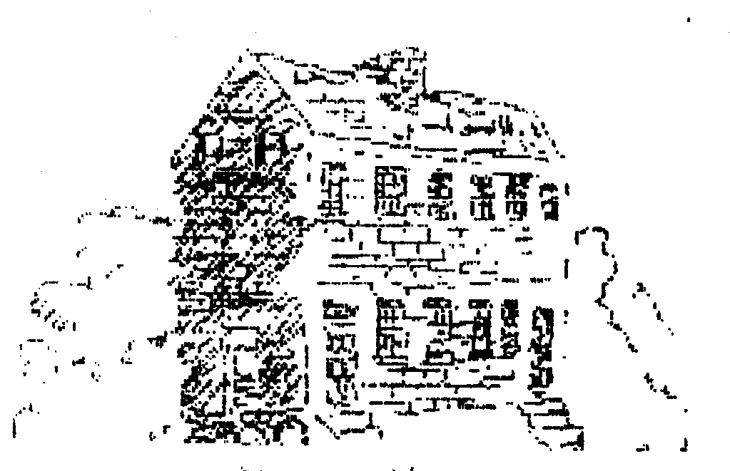 THE LAUREL LIGHT
November 29, 2002 Volume VI, Number 2 News from the Laurel Historical Society and The Laurel Museum

Special Open House

The Laurel Museum will host a special Holiday Open House on Saturday, December 7th from 10:00 AM to 4:00 PM. Enjoy the festive holiday atmosphere, light refreshments and Museum Shop specials.
The newest in our series of Laurel Brass Ornaments will be featured:

The B&O TRAIN STATION ORNAMENT. This historic structure was built in 1884 and is on the National Register of Historic Places. The gift boxed brass ornament is the newest in the collection of five Laurel landmarks joining The Laurel Museum, The Laurel Cotton Mill, Laurel High School and Old Liz-the 1920's Fire Truck. All of these will be available in the museum shop on December 7th for only $16.00. The complete set of five will be on special for $70.00, a saving of $10.00. Visit our Museum shop for this and many other terrific gift ideas.

Upcoming Calendar & Meeting Notice:

December 7th Holiday Open House
Saturday 10:00 to 4:00

December 18th Last regular day Museum is
open until February

January 9th Volunteer Appreciation
Party

January 23rd Board of Directors Meeting

February 2nd Museum Re-opens

Save the Date:

March 29th CELEBRATION!
The Society's Annual Gala

The Laurel Historical Society is proud to have the following Community Business and Professional Partners:
The Citizens National Bank
The Laurel Leader

A plea from the President:
We need more members to help us!

Like many small groups, too few must do too much. Please give us a hand.
First, if you are a member and have not yet sent us your dues for 2003, please do it now. If you have done it already, thanks.
(continued on page 2)

(President from page 1)
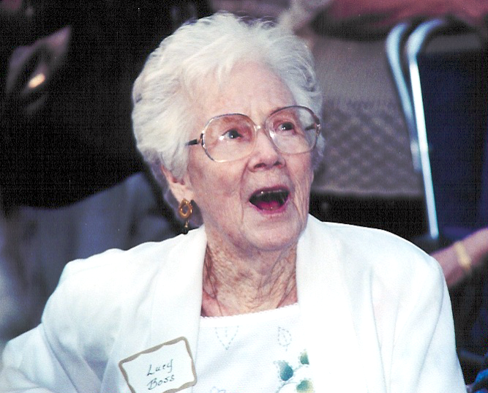
Then, think of a friend or neighbor who is interested in local history and ask them to join with us.
We need additional volunteers. We want to be able to open the Museum an additional day each week, but we can’t without more help. You could make a big difference with as little as 4 hours a month – as a Museum assistant, an administrative assistant to the Director, a regular or “on call” docent, a mail stuffer, or a research aide in the library. Think about it, it’s an enjoyable experience.
And we need all the help we can get to make our annual spring Gala a success. Mark your calendar for March 29th. We need help on everything from soup to nuts (OK, we will take care of the food, but we need help with lots of other things). If you can give us a hand, please give our chairman, Margie McCeney, a call – 301 776-7267.
No matter what or how much you can do, please give me a call - 301 776-7036. Thanks you.
Jim McCeney

Welcome New Members:

Jeanne & Randy Anastasi
Buford & Linda Goins
Ronald & Leona Jacobs
Regina & John Mima
Doreen & Nicholas Nionakis

The Laurel Light
Published bi-monthly by:
The Laurel Historical Society Inc.
817 Main St.; Laurel, MD 20707-3429

Jim Boss's Wife, Lucy, at the Dedication

JAMES G. BOSS MEMORIAL DEDICATED

On September 12 the Laurel Historical Society hosted the dedication of a memorial to Jim Boss at the Laurel Museum. Jim's leadership in the field of Preservation and his twenty years of service as Chairman of the Laurel Historic District Commission were honored at the ceremony.

A stone garden bench made from Laurel's original granite curbstones and a brass plaque were placed in the new memorial garden in his memory. Mike Walls gave a history of Jim Boss's contributions to the City of Laurel and Society President, Jim McCeney thanked all of his colleagues and friends that contributed to the memorial.

Special Thanks were given to Faith Calhoun for originating the project, to Betty Compton for coordinating the design and execution of the memorial, to Mike Walls for his efforts to raise the funds to make it possible, to Mike Lhotsky and the city employees who helped create it and to Barbara Bricker, a Prince George's Co. Master Gardener for her assistance with garden design and execution.

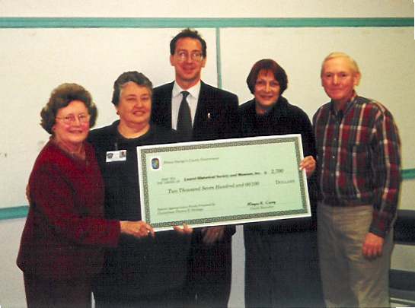
LAUREL MUSEUM RECEIVES NOTABLE DONATIONS

The Laurel Museum received a significant gift from descendants of one of Laurel's most famous citizens, Horace Capron, Howard MacCord Sr., a retired archeologist, presented a book published in 1875 that was written by his ancestor. The book describes Capron's work for the Emperor of Japan on the Island of Hokkaido. At the same time, Mr. MacCord's nephew, Lewis Hoff gave the Museum a copy of the genealogy he has compiled on the Capron family.

Mr. MacCord received the book in 1954 while stationed in Japan where he was introduced to Professor Kodama, a Japanese archeologist. When the archeologist learned of Mr. MacCord's relationship to Horace Capron, he presented him with the book of reports on agriculture and natural resources of Hokkaido.

Mr. MacCord was also accompanied by his wife, Betsy, his sister, Evelyn Hildebrand and niece Melanie Murry. For more information on Horace Capron and his importance to the City of Laurel, see the article by Ken Skrivseth on page 4.
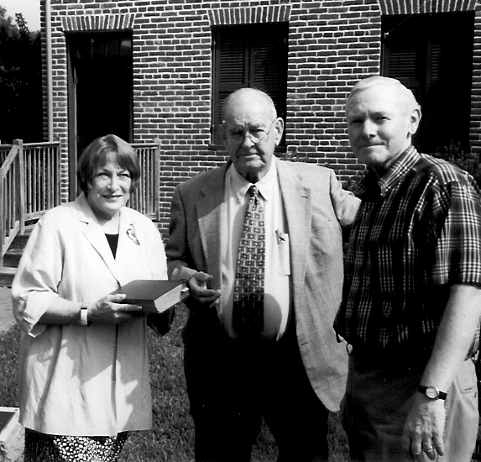
Museum Director Carol Runyon, Howard McCord and Society President Jim McCeney

GRANT PRESENTED BY COUNCILMAN TOM DERNOGA

The Laurel Historical Society was the grateful recipient of a $2,700 Grant to purchase a new copier for the Laurel Museum. This much-needed financial assistance was presented by Councilman Tom Dernoga at the October meeting of the Board of Directors. Shown above are (left to right) Betty Compton, Faith Calhoun, Tom Dernoga, Carol Runyon and Jim McCeney.

LAUREL HISTORICAL SOCIETY RECEIVES AWARD FROM CITIZENS CONCERNED FOR A CLEANER COUNTY.

The award was presented for the efforts to beautify the land around the Laurel Museum after the Tornado and for the creation of the new Memorial Garden area.

HORACE CAPRON
- by Ken Skrivseth
Horace Capron (1804-1885) is perhaps the single most important historical figure to have lived in Laurel.

The newly acquired Horace Capron report from his 1871-75 mission to Japan is an important addition to the Historical Society’s collection. Not only is it a rare glimpse into the activities of an important commission in Japan in that period, it also reflects on much of Horace Capron’s agricultural experience and perspective, experience he first gained while living in Laurel, experimenting with farming improvements and establishing the large cotton mill and the village that became Laurel and operating the mill for many years.

Horace Capon became deeply involved in Laurel and its cotton mill beginning in 1835. Capron was experienced in the operations of mills from his boyhood in Massachusetts and New York, and had previously been superintendent of two mills in Maryland, including nearby Savage Mill. He was also active as an officer with the Maryland Militia during this period. He married Louisa Snowden, whose late father owned Montpelier Mansion, in 1834.

In 1835-36, with Horace’s expertise, and with backing from the Snowden family including brother-in-law Dr. Theodore Jenkins, and with support from Capron’s New England relatives, a small existing mill on the Patuxent River was superseded by a substantial, mechanized cotton mill driven by water power.

Capron operated the mill from its opening until 1851. The Laurel Historical Society owns a register from that period which gives fascinating insights into transactions of the time. Especially during his later years in Laurel he also experimented with farming improvements, and this experience later led to his appointment in

1867 as Commissioner of Agriculture for the United States Government. In 1871 he resigned that post to lead a team of experts to assist Japan in agricultural reforms and in opening up the island of Hokkaido to colonization.

Horace Capron and Louisa had at least four children all born in Laurel. Unfortunately Louisa died in 1849. In 1851 the mill failed, and Horace declared bankruptcy. He soon remarried, and after a few years he obtained an appointment from the President to assist in calming the Indians in Texas following the Mexican War. He spent several months in Texas, then moved to Illinois where some of his family had migrated.

During his time in Laurel, Capron had experimented with agricultural techniques. In Illinois he again took up farming in earnest, and was again prominent in agricultural endeavors, writing articles, participating in well-known events and receiving awards for his work.

At the outbreak of the Civil War, Horace continued with his agricultural efforts until late in 1862, when he was called upon to establish and later to lead, an Illinois cavalry regiment. He was the oldest cavalry officer in the Union Army. Seeing action in a number of skirmishes and battles, and losing a son in battle, he left the army with an injury in 1864 and was later given the rank of Brevet Brigadier General.

After a brief stay in Illinois he was again called upon by the government, this time to become Commissioner of Agriculture for the United States. This position he held until 1871, when he was persuaded by an official group from Japan, to lead a team of experts in opening up the northern island of Hokkaido to settlement by the Japanese, and to modern agriculture. The team spent four years in Japan, bringing many up-to-date practices to that sparsely

(continued on page 5)

(Horace Capron from page 4)

settled island. It was at the end of this period that Horace Capron wrote the important report that the LHS has been very fortunate to receive.

After leaving Japan in 1875, Capron continued working from Washington, D.C on behalf of the Japanese interests.

Horace Capron died in February 1885 after being an honored guest at the dedication of the Washington Monument in Washington, D.C, which took place during a frigid (12 degree) February day. He had also been present many years earlier at the laying of the Monument’s cornerstone in 1848, leading a cavalry troop of the Maryland Militia. He is buried in Oak Hill Cemetery in Georgetown.

Mobilizing an Exhibit:
“Over Here: Life in Laurel During World War II”

What happened to you and your family during World War II at home in Laurel? How did the war affect your life and the lives of those around you? Laurel Museum needs your stories, information, photographs, artifacts, memorabilia, and any documentation if you still have them. We can make copies for our Laurel Home Front Collection or you may want to donate these materials to the museum.

Some of the questions you might answer could be:
What are your memories of Laurel during WWII? Did any family members go overseas? How did that affect your family life?

Where did you work? Did your work change? Did you work for the first time for the war effort?

How were communications affected? Did you use V-Mail? What kind of transportation did you use? How was gasoline rationed? Were repairs to vehicles hard to get done?
What kinds of foods were hard to get? How did you manage with the rationing? What substitutes were popular? Did your family have a Victory Garden?

How did clothing change? Did family members make or mend their own clothes?
How did being so close to Fort Meade affect Laurel?
How did Laurel change? How did going through this experience change you?
How did it make you feel about living in Laurel?
I’m sure you can think of even more to talk about. Give the Director a call and we’ll make arrangements to meet with you to document your answers and collect any photographs and materials you may wish to donate or have us copy.

We’re also looking for 1930s and 40s house wares to borrow: an early 20th century Hoosier, ice box, kitchen cabinets, or shelves; old wooden kitchen chairs; old canning equipment and kitchen wares; war-time pin-up calendars. And for the 1940s living room: an old easy chair and ottoman, rug and lamps. Someone has already offered a console radio.

The Museum is looking to increase its public hours with the opening of this new exhibit in spring 2003. We could use some additional volunteers to work just a few hours on Fridays and Saturdays at least once a month.

You can reach the Laurel Museum during the week, daily from 10:00 a.m. to 4:00 p.m. at 301-725-7975.

Carol Runyon
Museum Director

The Laurel Historical Society
The Laurel Museum
817 Main Street
Laurel, MD 20707-3429

